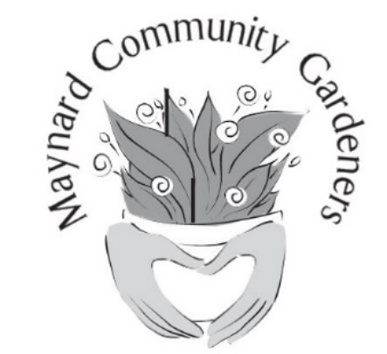
www.maynardcommunitygardeners.org

Email
Join the Maynard Community Gardeners
Renewal?
Name
Address

Y/N

Zip Code
City/Town

Phone
Volunteer Areas of Interest. Check all that apply.

New Member Outreach

Help with Tabling at Events

Downtown Buckets & Gateway Planters (i.e. plant and maintain one location)

Organize outings such as Garden Tours, Trips and Speakers

Host a member seasonal potluck or social

Maintenance (i.e. care of established town gardens by either weeding and/or watering)

Assisting with the annual plant sale

Swapping (i.e. facilitate plant, seed & garden items exchanges with other members)
Program Areas of Interest.

How to Garden (circle all that interest you):

- Beginning gardening
- Watering, Sun
- Plant selection
- Plant propagating: Seeds, dividing, cuttings, bulbs, etc.
- Grow Zone
- Soil testing & amending
- How to compost
- How to keep critters and bugs out
- What grows well in Maynard
- Planting, fertilizing, weeding, pruning
- Harvesting
- Food preserving such as canning and drying
- Winter gardening, prepping for spring
Outings, Gatherings &
Educational Opportunities

- Garden tour outings – Tower Hill, Garden in the Woods, etc.
- Member Potlucks & Social Gatherings, Garden Tours
- Sharing gardening info. and best practices with other members
- Online lectures and slide shows from knowledgeable guest speakers
- Garden-related outings (e.g. garden visits, tours, local farms)
- Participate in hands-on workshops (e.g. trellis making, wreath making, wall building)
- Opportunities to meet other gardeners, attend potlucks and social gatherings
- Bulb Sale and plant/seedling swaps with other members
New Members Mail Completed Form and $20 Annual MCG Membership Fee to:
PO Box 522, Maynard, MA 01754

